Unit 2: Social Sciences
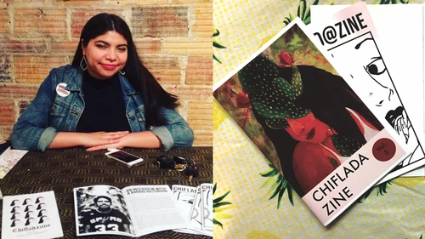
Prompt: One of the biggest issues in academia is that oftentimes the research that would benefit at-risk and vulnerable communities is gatekept by jargonistic language and paywalls. The goal of this section is to actionably put the information in the hands that need it. We will be focusing on the LatinX community, as “Statewide, 9.8% of North Carolina’s population is Hispanic or Latino, roughly half the national average (18.5%)” and considering the growing population of Latinx folks, it is important that we focalize their experiences when we look at the social sciences. “LatinX” is a term to refer to peoples of Latin American and Caribbean origin or descent (used as a gender-neutral or nonbinary alternative to Latino or Latina). However, the “X” accounts for more than just gender. The “X” is about the heterogeneity of the community, as the intersections and breadth of “Latinx’s” is what sets it apart from any other minoritized group. The “X” is about accounting for the differences within the community. In class, we will tease out the implications of using this term vs. other terms like “Latine” or “Hispanohablante.”
For this Unit, you will be designing a “zine” and distributing it across town in “little free libraries” or any free donation service of your choosing. The goal is to make information accessible. You will find several articles about a single sociological issue faced by the LatinX community, find organizations and resources that focus on the issue, and design a zine to compile this information in an approachable way. Zines inhabit and embody acts of resistance in the form of grassroots organizing, storytelling, music, performance, and revision of kinship networks. According to Wikipedia, “a zine is a small-circulation self-published work of original or appropriated texts and images, usually reproduced via a copy machine. Zines are the product of either a single person or of a very small group and are popularly photocopied into physical prints for circulation.” An article on mentalfloss recounts a brief history of zines and shows their multimodal uses: “zines are no longer strictly counter-culture, but they originated as small-scale DIY efforts—many with an anti-authoritarian message […] ​​Many zine-makers will say zines are as much about the community as the product, and that identifying as a zine is what separates these publications from comics, literary journals, websites, and other types of independent publications.” Zines were born out of the sci-fi community in the 30’s and became part of the punk scene in the 70’s. They regained popularity in the 90’s through the riot grrrl movement. Zines have always been about community, agency, and knowledge production/ dissemination; that is why they will be our medium for this unit.

Rhetorical Chart
Genre | Purpose | Audience | Role | Rhetorical Situation
Social Science Zine | To create an accessible form of media that will aid vulnerable populations. | The local LatinX population in the triangle. | Content-creator and activist. | You are tasked by a social service organization or advocacy group to create a zine that encourages mutual aid and connects at-risk populations with resources.

Potential Models:
http://experimentwithnature.com/03-found/experiment-with-paper-how-to-make-a-one-page-zine/#.YQmuehNKhKO
https://zines.barnard.edu/zine-libraries
https://brokenpencil.com/
https://filmmefatales.com/

How to Make a Zine TikToks:
https://vm.tiktok.com/ZM8rh4usB/
https://vm.tiktok.com/ZM8rhxkKK/
https://vm.tiktok.com/ZM8rhAA46/
https://vm.tiktok.com/ZM8rhhPaX/

Feeder 2.1: Annotated Bib and Local Organizations
Find four or more scholarly articles from the geography, sociology, or cultural studies disciplines that focus on one issue that LatinX community faces in the U.S. (though I encourage you to think as locally as possible). Use the library to find your sources. Give a 2 paragraph summary of each article that translates any jargonistic or complex language and explains how you will incorporate it into your zine. Additionally, find actionable resources already in place that address the topic-- meaning research local organizations and nonprofits. Select 3 to include in your zine and explain why you have chosen to highlight these organizations. Be judicious in what you are looking for:
E.g. if the issue you choose to focus on is domestic violence, make sure to think sensitively about this community and only provide resources that work with diverse communities and will not further endanger a survivor (think about whether or not they have the tools to provide service to a Spanish speaker? Do their ethics and politics align? Meaning, will they protect an undocumented survivor?). Provide at least 3 resources. I encourage you to provide at least one resource for every part of the research triangle.

Feeder 2.2: Zine Design
Submit a draft of your zine design shell. The zine design should not include any of your content, but show the outline of your design. Your final design must be 6-8 pages including a cover and works cited. The size may vary but the standard sizes are from a 8.5" x 11" sheet of paper folded and stapled to be 6" x 9" or 5.5" x 8.5". You may use any program that you are comfortable with (canva, photoshop, indesign, etc.) or create your template by hand (refer to the image below). Your design should have a clear style and color scheme.

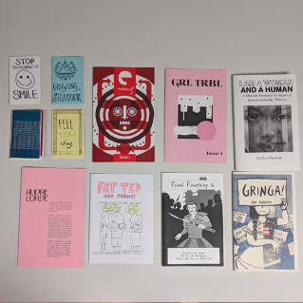
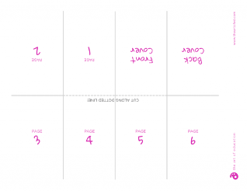

Unit Project: Social Science Zine
Create a social science zine that addresses an issue faced by the LatinX community in the U.S. (I encourage you to think as locally as possible). The zine will present the information in an accessible and approachable way and offer local resources to readers. You will then disseminate your zine to a local little free library in the area.
You will:
- Find 4 or more scholarly articles that relate specifically to an issue within the LatinX community in the United States, however, I encourage you to look and think as locally as possible. The article must be situated within the geography, sociology, or cultural studies disciplines.
- You will then translate any jargonistic language into plain, understandable terms accessible to a wide audience.
- Find any actionable resources already in place that could help address these issues, this will require you to research local organizations and nonprofits. Be judicious in what you are looking for.
- Make a design of your “zine.” You can draw by hand or use canva, photoshop, or any design platform that you are comfortable using. Your design must be 6-8 pages. The size may vary but the standard sizes are from a 8.5" x 11" sheet of paper folded and stapled to be 6" x 9" or 5.5" x 8.5". Dimensions may be customized to suit your purpose. Your zine must explain the issue, why it is important to consider and list your resources. Be as specific and detailed as possible. A draft of this zine will be due as a feeder assignment.
- We will host a Zine Fair at the end of the unit to share our work with the class and guests. We will ask questions about each other’s projects and processes.
- Your final zine will be distributed around town to free libraries and/or donation services.
Little Free Library Locations:

