Writing in the Natural Sciences Assignment Sheet
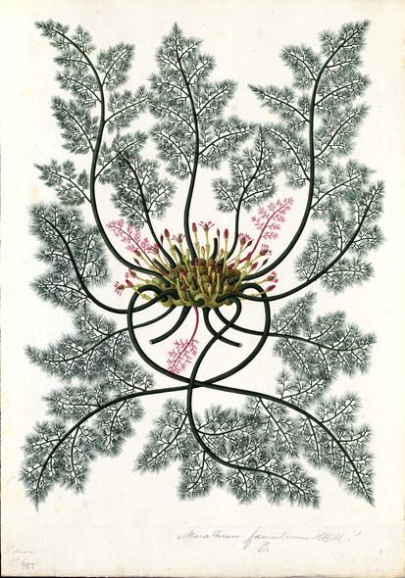

This unit aims to introduce students to writing in the sciences in a way that disrupts the coloniality of Western natural science while introducing them to what Dr. María DeGuzmán has described as LatinX Botanical Epistemologies. The Latinx community, as Dr. DeGuzmán elucidates in the article, has always been at the forefront of botanical "discoveries" and maintenance. Many botanical gardens obtained their species from the global south, and particularly from South America where plants were poached and brought to the US and Europe for development in monoculture and/or gardens. Many of these gardens have also been maintained by Latinx laborers (see this article for an expose on the Huntington Gardens).
We will interrogate and untangle the inherent relationship between botanical sciences, horticulture, and agriculture, and the colonial project. As such, students will explore the historical, spiritual, cultural, and scientific fabrics of one plant species that holds particular relevance to LatinX communities, conducting research in line with ethnobotanical approaches (though the marginalization of ethnobotany as opposed to botany ‘proper’ will be critiqued & questioned in class discussions). The final assignment of the unit will consist of a blog post/popular science entry on a plant species of their choice (likely from the list of species offered on the database website).
Because this assignment aims to engage students in transdisciplinary work (toggling between approaches in botany & ethnobotany, the Natural Sciences & Social Sciences), the database entry that students create will be the final project for both Units I & II. For Unit I, students will create mini-essays focused on their selected plant’s role in the Natural Sciences, and will build upon these drafts as they transition to writing in the Social Sciences. After completing Units I & II, students will have the opportunity to submit their essays for peer review and publication on the LatinX Botanical Database website, so that they comprise a living document / communal database of botanical epistemologies influenced by LatinX histories, cultures, and ongoing ways of living.

Role | Audience | Purpose | Genre | Rhetorical Situation
Researcher in the natural sciences | LSP, other 105 students, botanists, and plant enthusiasts. | To think about the multiple uses of plants cross-culturally and deconstructing the binary between Linnaean and ethnobotanical uses of plants. How can we honor the aesthetic, medicinal, and nutritional values/lineages of flora? | Blog Post | You are a botanist/researcher studying the cross-cultural history of a certain plant.

Genre Models:
Vanderbilt’s Latin American Garden Database

Prior Student Examples in database (under “Student Work”): https://latinxbotanicaldatabase.myportfolio.com/

Feeder 1.1: Annotated Bib
Select a plant from the list. Find 4-6 resources that discuss the plant’s uses in different communities (this will range depending on the plant you select). It is important to look beyond our contemporary, western botanical understandings of the plant— reach farther and look to non-white / non-colonial uses outside of monoculture/ the plantation model, or gardening. Wikipedia is a great starting point, but look at other sources whether that is a news article, a journal article, etc. and ensure that all sources you use are peer-reviewed, scholarly sources (we’ll discuss how to determine this in class).

Feeder 1.2: Draft + Peer Review
Because these blog posts will exist within our database, it’s important that we treat this material with care, reverence, and meticulous research. Please submit a 2-page transcript for peer review. This transcript should show both sides of the comparative element: the “ethno” and western, and explain why you chose this plant. Give a closing statement that sums up why this material matters and how it can invite us to think differently about ecologies.
Unit Project:​​ A Botanical Archive Blog Post (Part I of II parts, second part to be completed in Unit II)
Write and edit a 3-4 page blog post focusing on one plant’s ethnobotanical history. You will research the cross-cultural uses and compare the “ethnobotanical” uses to the “Linnaean” uses. How do communities of color approach natural and botanical epistemologies differently? How has the plant been characterized and utilized by different communities over time? How do we think or not think of the plant now? How should we reconsider our environments with these new frameworks in mind?

Your blog posts will live on this page permanently for posterity where we will continue to build a catalog of decolonial plant histories over time.
You will:
- Select a plant from this list to focus on (or make a case for another plant not listed on the website).
- Create an annotated bibliography researching non-western and western uses of the plant.
- Write a comparative review of the plant’s history and uses making sure to prioritize “ethnobotanical” histories and uses (2/3rds of your final blog post should focus on “ethnobotany” with 1/3 rd comparison to Linnean characterizations).
- Submit a 2-page transcript for peer review. With their feedback in mind, edit and complete the final blog post.
- Your final blog post will be a 3-4 page account of the plant’s uses across time and space. Your essay should focus on “ethnobotanical” uses and inspire us to engage with our environments with greater care. This project will contribute to the living database of decolonial botanical histories.
Rubric:
A level work: Student successfully and lucidly does a comparative analysis of botanical histories and focuses on the ethnobotanical portion of the plant’s history.

B level work: the student shows the history of the plant across time and space.

C level work: the student partially represents the plant’s history.

D or F level work: the student did not successfully or adequately show the ways the plant has been utilized.

